* Dmux_1x2_4bit DMux1(in1, out1, out2, control);

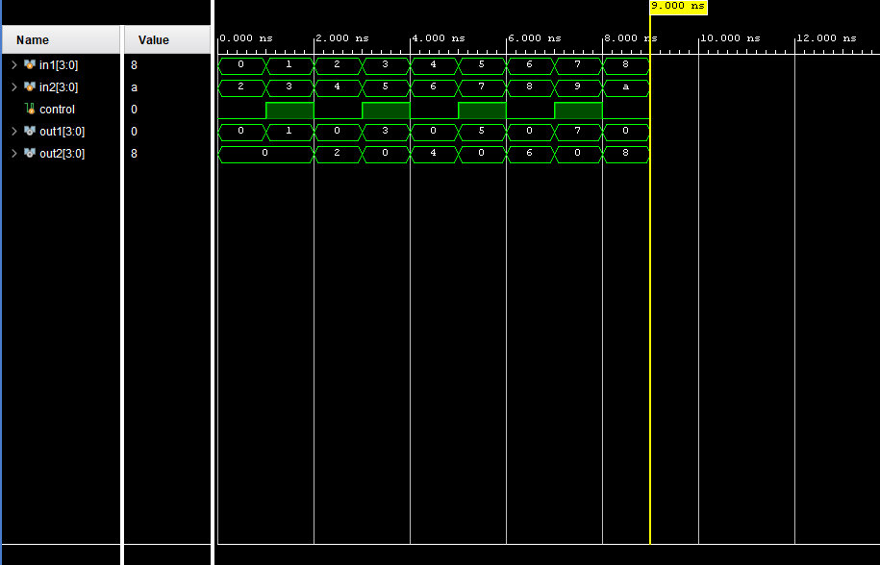

* Mux_2x1_4bit Mux1(in1, in2, control, out1);

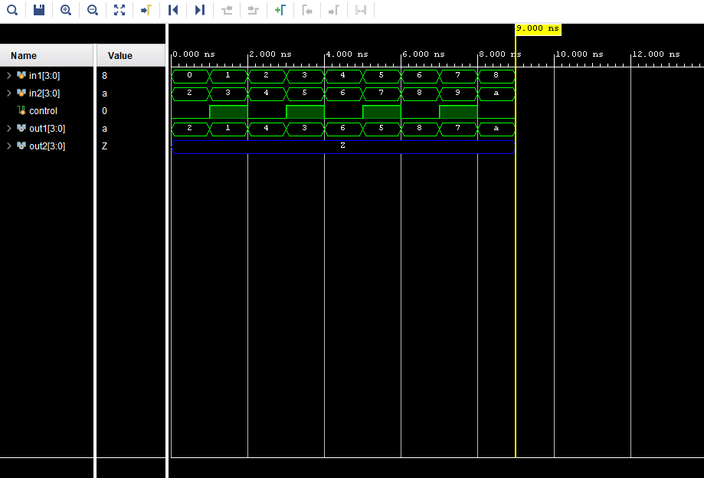

* Combine MUX&DMUX to Crossbar_2x2_4bit

